**Practical Work Experience and Portfolio Building**

**Evidence Reporting Document**

* **Introduction**

*The main goal of this document is to keep track of the practical hands-on work experience and lab challenges you will complete throughout the program. By doing so, at the end of the program, you will have a great portfolio that you can use for evidence of your practical skills, and you can also come back for review whenever needed. This evidence is essential in the long run and keeps you on track with the time you will spend on your career upgrade process. These notes will also play a vital role in identifying the skills and tools to reflect on your marketing materials like your CV/resume or LinkedIn Page.*

* **General Details**

**Date: 17 May 2024**

**Your Name: LOK HIM TAM (Himson)**

**Email-address:** himsom0528@gmail.com

**Name of the Challenge:** Configure Application Insights and App Service Logs for a Web App [Guided]

**Access Details (URL or source):** AZ500

**Details of the Challenge:**

In this lab I have working following exercise:

* Created an Azure web app.
  + Create an Azure web app
* Deployed application code.
  + Deploy the source code for the **wa41229208** web app
* Enabled Application Insights.
  + Enable **Application Insights**
  + Open the **Live metrics** report on the **Application Dashboard**.
  + Generate a failed request for the web app
  + On the **Application Dashboard**, open the **Failures** report
* Enabled App Service logs.
  + Enable **App Service logs**
  + Open the **Log stream** for the wa41229208 web app.
  + Generate a failed request for the web app
  + Return to the **Log stream** page, and then review the successful and failed requests.
  + 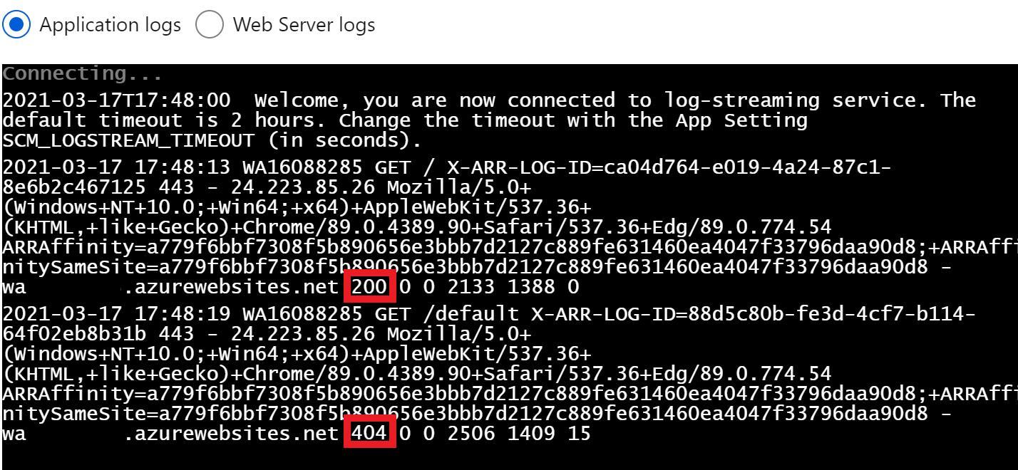

**Lab Topology**

Create an Azure web app by using the values in the following table. For any property that is not specified, use the default value.

| **Property** | **Value** |
| --- | --- |
| Resource Group | **corp-datalod41229208** |
| Name | wa41229208 |
| Publish | **Code** |
| Runtime stack | **ASP.NET V4.8** or the latest version that is not preview or early access |
| Region | **East US** |
| Windows Plan (East US) | AppPlan1 |
| Sku and size | **Standard S1** |
| Continuous deployment | **Disable** |
| Enable network injection | **Off** |
| Enable Application Insights | **No** |

Deploy the source code for the **wa41229208** web app by using the values in the following table. For any property that is not specified, use the default value.

| **Property** | **Value** |
| --- | --- |
| Source | **External Git** |
| Repository | https://github.com/LODSContent/LODSOC_app-service-web-dotnet-get-started |
| Branch | main |
| Repository Type | **Public** |

Enable **App Service logs** for the wa41229208 web app by using the values in the following table. For any property that is not specified, use the default value.

| **Property** | **Value** |
| --- | --- |
| Application Logging (Filesystem) | **On** |
| Level | **Error** |
| Web server logging | **File System** |
| Quota (MB) | 35 |
| Retention Period (Days) | 90 |

* **Challenge Details**

**Before starting the challenge:**

1. Be sure that the lab is in the scope of your niche.
2. You have enough time to solve the full lab or have a proper plan to solve a part of it and complete the remaining sections later.
3. Try to build a good learning environment with less distraction for at least 30 minutes to an hour.

**After completing the challenge:**

1. Were you able to finish the lab? Did you need extra time? Was the lab relevant to your expectations? Did you need additional help to solve the lab?

* Yes I am able to finish the lab within 45 mins. It is relevant to my expectations. And I can finish it without additional help.

1. Write down your learning outcomes, skills you developed or improved and the tools you used in this challenge.

*(You may use the keywords listed in the lab details or add your own skills that you think you acquired.)*

* I have learnt how to create an Azure web app.
* I have learnt how to deployed application code from external source code for web app
* I have learnt how to enabled Application Insights and use application dashboard to monitor the status of the application
* I have learnt how to enabled App Service logs and learnt how to test the log with success request and failure request.

1. Prepare a self-reflection and reporting video using any screen recording tool (like Loom) and share the link.

*(The report may include but is not limited to your thoughts about the problem solved, difficulties encountered, any notes to discuss with your peers, anything to ask the mentors and last but not least how it may help you in your ideal job. Please prepare the summary in a way that you are presenting this to your managers and colleagues in your ideal workplace)*

**URL:** [**https://www.loom.com/share/d4dbb33371794adab2394e480f7dd615?sid=c7a45bb4-d93f-4785-a95f-4296cfd7504e**](https://www.loom.com/share/d4dbb33371794adab2394e480f7dd615?sid=c7a45bb4-d93f-4785-a95f-4296cfd7504e)